|  |
| --- |
| Team ID : LTVIP2025TMID32402 |
| Project Name : Enchanted Wings: Marvels of Butterfly Species |

# Testing the Model

Here, we test the trained VGG16 model using the `predict()` function. The input image is loaded, preprocessed, and passed through the model to get the prediction. The class with the highest probability is returned.

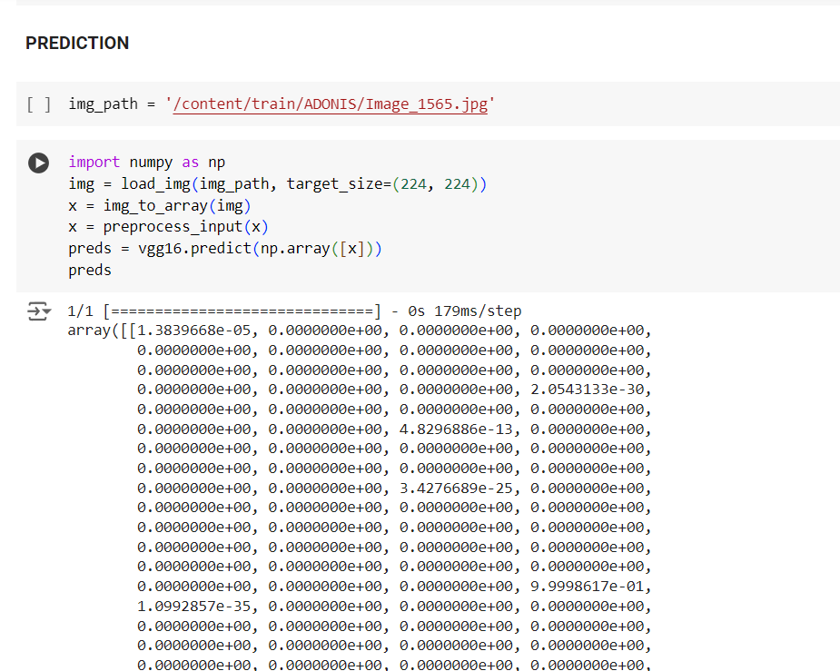

This shows the raw output array from the model prediction. Each index represents the probability of a class.

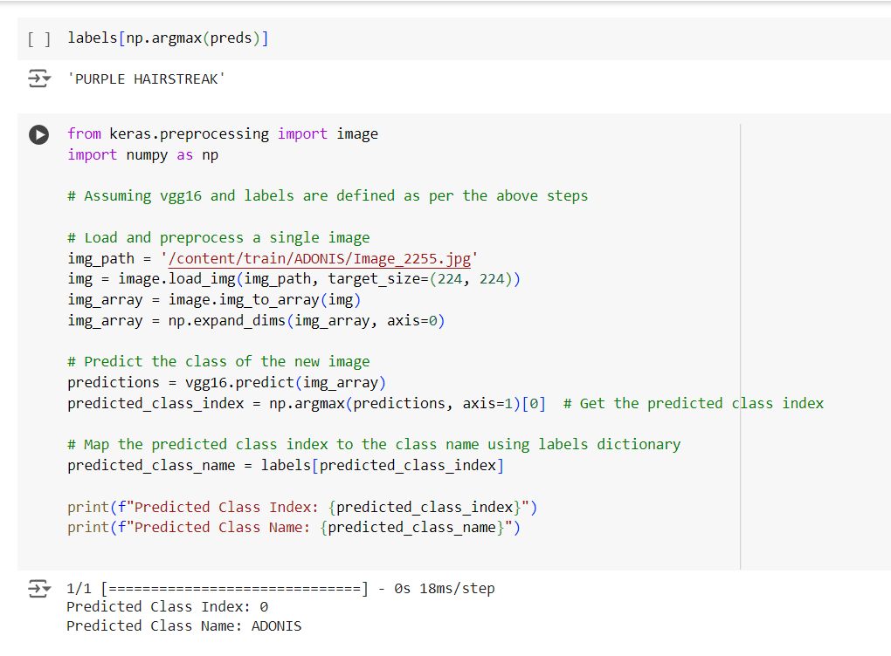

The predicted class index is matched with the corresponding class name using a label dictionary.

Example:  
• Predicted Class Index: 0  
• Predicted Class Name: ADONIS